**Setup Nginx webserver with PHP and Securing with Http Basic Auth**

1. Install Nginx Webser

sudo apt install nginx

1. Install PHP-FPM and related module

sudo apt-get install php-fpm php-mysql

1. Configure nginx PHP settings

Sudo nano /etc/php/7.4/fpm/php.ini

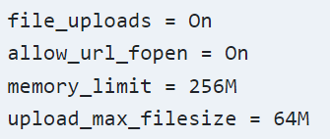

1. Uncomment the changes to enable nginx php support

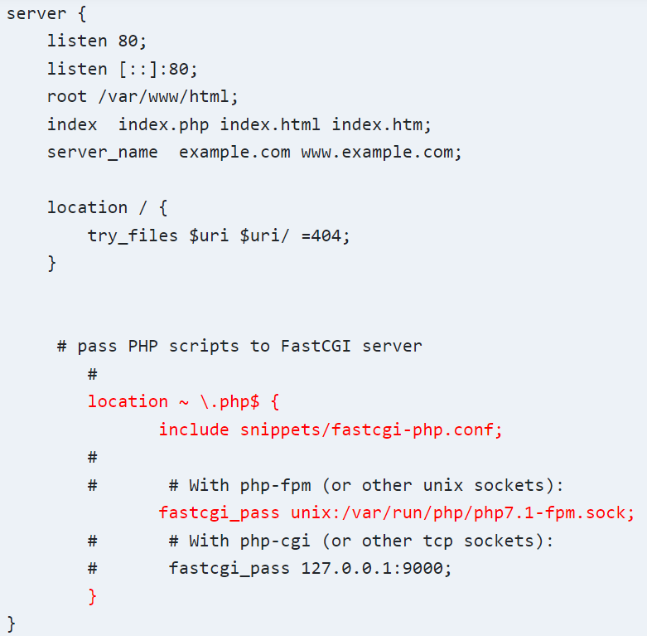

1. Test PHP-FPM setup

Sudo vi /var/www/html/index.php

<?php

Echo “Hello world”;

?>

Reference- https://websiteforstudents.com/setup-nginx-web-servers-with-php-support-on-ubuntu-servers/

Setting up HTTP Basic Auth

1. Sudo apt install apache2-utils
2. Sudo htpasswd -c /etc/nginx/conf.d/.htpasswd developer #here developer is the user
3. Sudo htpasswd /etc/nginx/conf.d/.htpasswd admin
4. To view the file content – cat /etc/nginx/conf.d/.htpasswd
5. Basic authentication for whole server ---

Open the /etc/nginx/nginx.conf file and add the lines

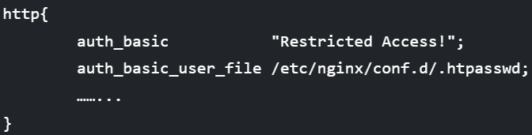

1. Password protect nginx website or domain

Open file /etc/nginx/sites-available/default then add the configuration below-

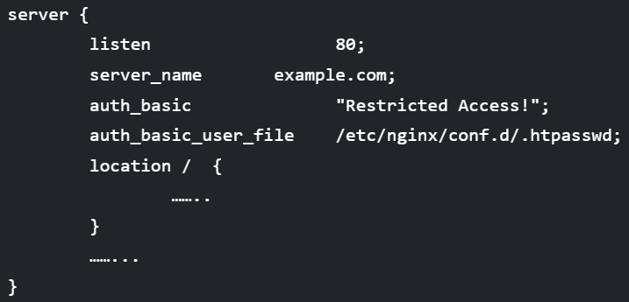

1. Restart the nginx to reflect the changes-

Sudo systemctl restart nginx